Handspun thread for sewing
Axera Coscolano, Mists Spring Investiture AS54

The spinning of thread predates written civilization. Spindle whorls have been found dating back to the Neolithic period. Spinning is a necessary step to making all kinds of cloth, thread, cord and string.

My aim was to produce a strong, smooth thread that could be used for sewing. The example here is made of wool and is created using documentable spinning techniques dating to the 14th Century or before.

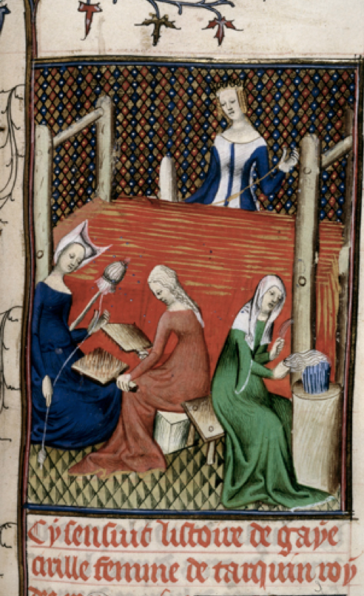
Fig 1: Detail of a miniature of Gaia Caecilia or Tanaquil at her loom, while women spin and card wool, late 14th C. Courtesy of the British Library.

I chose wool from a breed of sheep native to the Cotswolds in England—while it is unclear if this breed existed exactly as-is in the 14th Century sheep were introduced to that area in Roman times. This wool is long and slightly hairy which matches the threads found at a variety of Medieval archeological finds, including Herjolfsnes. Unlike most commercially available wool this fleece has not been cross-bred with more modern breeds, such as Merino. It was also a fleece I already had on hand, which was convenient.

I washed the wool thoroughly in the modern fashion using dish detergent for the sake of speed, convenience, and my nose, since the medieval methods for removing lanolin usually involve stale urine. While some enjoy spinning wool that has not been washed, I find it easier to make a smooth thread without the grease. It is also easier to remove all of the dust, sweat, and gunk while the fleece is loose, since it is harder for soap and water to penetrate thread.

To open the fibers and align them for spinning I used modern wool combs consisting of wooden handles and two rows of long, metal spikes. Combs such as this have been found all over Europe dating back to the 10th Century. Although it is debated if some of these are flax hackles (which are used individually) as opposed to wool combs (which are used in pairs) there are examples of pairs of combs, such as NF.07621-003 from the Norsk Folkemuseum. There is also an illustration dating to 1442 of a man combing wool with combs nearly identical to the ones I own. The following illustration is from Folio 64 of V 1.2.0.140623 at the Stadtbibliothek Nürnberg.
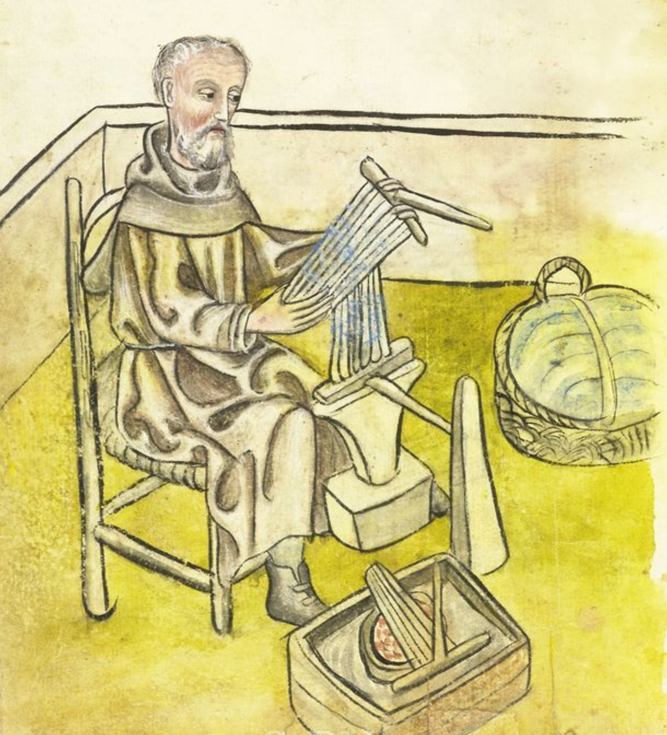
Fig 1: Man combing wool, 1442

It is unclear exactly when the transition was made to primarily spinning with a wheel instead of a spindle, although wheels began to be pictured in art from the Middle and Far East primarily in the 13th Century. The Luttrell Psalter (c 1320-1340) clearly shows women using both the primitive type of spinning wheel known as a great wheel as well as a handspindle and distaff, indicating that both were common methods of producing thread in the 14th Century.

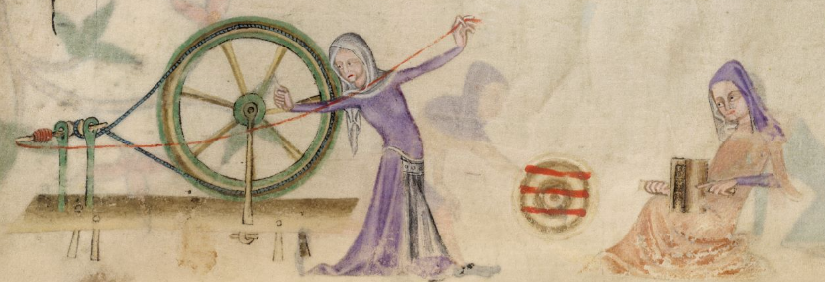
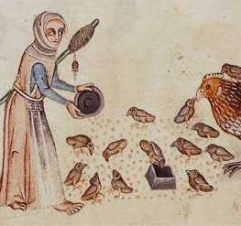
Figs 2 & 3: Depictions of spinning from the Luttrell Psalter

I chose to use a spindle for this yarn as I do not own a great wheel. The spindle I used is of a similar size to those depicted in 14th and 15th Century illustrations.

There are two primary ways of using a spindle—either with the spindle hanging in mid air, or with it supported on a bowl or surface. Both were used in period. I chose to spin supported because I find it much easier to do while sitting down, and I prefer to spend my free time sitting. Modern production spinners in the Andes will use a combination of supported and drop spindling techniques as needed because they tend to spin while involved in other tasks—watching animals, socializing, cooking, selling at market, etc. Many experimental archeologists believe this is a more accurate example of how women pre-industrial revolution would spin, as opposed to strict adherence to one codified style.

The main difference between my threads and those in archeological finds from Greenland and the Netherlands is that most archeological threads are Z-twist (twisted to the right) while mine are twisted to the left. I learned how to spin left-handed as a child and I still cannot spin right-handed with the same proficiency. Thus, my thread is backwards. Sewing threads were specially made to be used for sewing, and unlike the warp and weft of the cloth they consisted of two finer threads twisted back on one another. This plying process makes the thread stronger but also much, much more manageable and less prone to snarling.

My sewing thread was also plied on a spindle. When finished it is about the weight of a modern topstitching thread—thicker than a standard sewing thread but definitely useable. It’s smaller than the silk I usually use for buttonholes and eyelets.

To demonstrate that it could be used for sewing I did a couple sample stitches in a commercially available wool twill. I found beeswaxing the thread made it much smoother to use, although it is unclear if the thread used in the Herjolfsnes finds was waxed or not.

Works Cited
Brandenburgh, C.R. (2010) Early medieval textile remains from settlements in the Netherlands. An evaluation of textile production. Journal of Archeology in the Low Countries.
Callañaupa Alvarez N. (2007) Weaving in the Peruvian Highlands: Dreaming Patterns, Weaving Memories. Center de Textiles Traditionales del Cusco.
Nordtorp-Madson, S. (2010) Medieval Garments Reconstucted: Norse clothing patterns. Aarhus University Press
Robson, D. (2011) The Fleece and Fiber Sourcebook: More than 200 fibers from animal to spun yarn. Storey Publishing
Seinnicka, M, (2015) First textiles: The beginnings of textile manufacture in Europe and the Mediterranean. Ancient Textiles Series 32, Oxbow Books.

